6.39: a) The spring does positive work on the sled and rider; 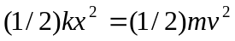, or . b) The net work done by the spring is 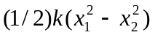, so the final speed is
